Tiger Bytes Robotics Competition

Capstone Design Proposal
Spring 2023
Electrical and Computer Engineering
Auburn University

Team 2
Wynn Baker
Libby Burdett
Lailah Douthitt
David Ericson
Dalton Gunter

Submitted to Dr. Roppel on February 17, 2023

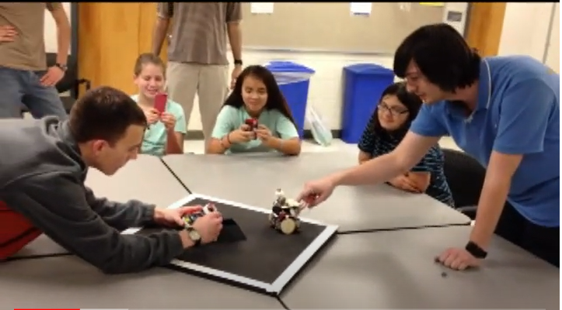

Executive Summary
The goal of this project is to plan and execute a robotics competition for the Auburn Electrical and Computer Engineering Department. This competition will be something that can consistently be held in Broun Hall. It will allow members of the department, college students, high school students, and middle school students to participate in it. As a team, we will be providing the guidelines to the competition through extensive research, building equipment such as score counters and competition platforms, and marketing the competition to local schools through different media sources.
Introduction
Beginning the planning process behind the Tiger Bytes Robotics Competition we saw the need for an annual robotics competition held in Broun Hall. Since Covid, we’ve been slowly trying to come back from a halt in planning events at Auburn. We see a need for an outlet for middle and high school students to participate in a competition like this. Before Covid, events like this had been planned but there was no consistent organization or follow-up to the students participating. We’re hoping with the resources we’ve been given; we can plan a competition that is well thought out and is a substantial outreach to the school communities around us.
Body
For this competition, our main goal was to have a successful outreach event for students in the area. We intend to reach out to secondary schools within a 30–40-minute drive away, either in Georgia or Alabama. For the students of Lee County, we would like to pair a student with a college student at Auburn and have them work together for the competition. We want to allow every student the best opportunity to learn and chance to win the competition. We knew there would be an unfair advantage with the college students when it came to building their own robot, but by allowing a younger student to pair with a college student, they would be learning and have equal opportunity to win their category. We also will have a category that involves an easier adjustable sumo bot that the ECE department has used before in other outreach events. This can be done the day of by the younger students. It would teach basic understanding of the robots and give every student an opportunity to participate.
One big resource we will need throughout this process is marketing materials. One of our first plans in advertising Tiger Bytes will be at E-Day. We want to talk to attendees and pass out flyers with a brief summary of the competition to any students or teachers coming to E-Day along with a QR code for them to get on an emailing list about the competition. These flyers along with any other advertising resources will be important to this process. In the days closer to the competition, we will need to be building stages for the competition, gathering supplies to allow the students to modify the sumo bots, and even supplies for the students in build your own competition. From the information we’ve been given, we assume the ECE department will have most of these resources for us to use.
A challenge we could encounter would be not finding the number of participants we would like to make this event a success. This is something we will have to consistently be pursuing in preparation for the competition. We plan to have incentives, consistent marketing, and detailed planning to ensure we have participants. This project will be something, we as a team, will have to consistently putting effort into due to the amount of planning on the front end. We expect many more challenges along the way considering we do not have very much prior knowledge on this subject.

One of our big subject matter experts will be Dr. Roppel. He was the one to suggest this project to us and has participated and planned many similar projects in SPARC and other competitions on campus. We plan to also begin research on other competitions like this at other schools. People who have executed something like this before will be an amazing resource for us. We will need help with guidelines to the competition, how to properly execute this, and any other advice in making the Tiger Bytes competition a success.

